**Languages** - JQuery, HTML, CSS, and JavaScript

**Teams:** 2 teams of 2 students each are allowed from each school.

**Rules** -

1. Participants are allowed to use all libraries of supported languages.
2. The participants may take help from online resources such as Stack Overflow and W3Schools.
3. The use of templates/tools from other sites such as Wix, Webflow, colorlib, etc. is not allowed.
4. Participants must send a .zip folder of their website **named “schoolname_website” along with its hosted link(optional)** to **projectbeta+webdev@sanskritischool.edu.in**
5. The participants are expected to host their website on a free hosting service (Netlify, GitHub, Hostinger etc.). Hosting is optional, but participants will receive bonus points for doing so.
6. The event will span over 8 days
7. The topic will be released on 14th August and the participants will have till 22nd August midnight, to work on it.
8. Straying away from the provided theme will result in a deduction of points.
9. The final result would be out on Slack, after 24th.

**Judgment criteria**

**Total points - 40**

Contestants will be judged based on:

1. **Aesthetic of the website – 7 Points**
2. **Content – 3 Points**
3. **Accessibility and navigation (user friendliness) – 5 Points**
4. **Quality and neatness of the code – 2 Points**
5. **Responsiveness – 5 Points**
6. **Submission time and method (link and .zip) – 3 Points**
7. **Addition of features mentioned in the doc, and surprise announcement. – 8**
8. **Originality - 7**

The decision of the HoD would be final and binding; no clarifications would be entertained.

**Positions:** There will be 5 positions, top 3 winners and 2 Hon’ble mentions.

**Theme / Plot** – The participants have to create a website recreating the looks of a gaming console, **XBOX ONE inspired** which is user-friendly for all ages.

Replicate the vibe of a gaming console, use good quality pictures, add all the features and icons present on a gaming console dashboard.

The website DOES NOT need to be interactive via keyboard (controlling the site using arrow-keys etc.).

Note, Surprise Announcements will be made to test the compatibility and versatility of the website.

**Note- Participants have to replicate the home screen of the console itself, and not the website of the console.**

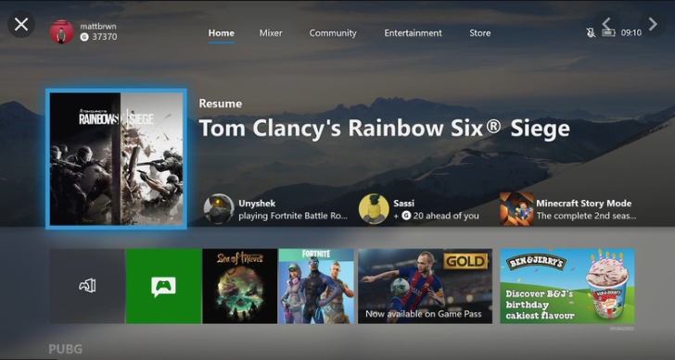

**Points to remember** –

1. Extra points will be awarded to those who can add separate Dark/Light themes to their site.

1. Remember, quality is more important than quantity.
2. We would prefer that you make your own graphics and illustrations.
3. Straying from the rules will result in immediate disqualification.